**Software architecture documentation**

20192698 Sim WonJun , CSE , Soongsil University

1. **Overview**

This program makes user to visit hacker-made page that snaps money out of his account and make him not be suspicious about it.

1. **Program Flow and high-level design**

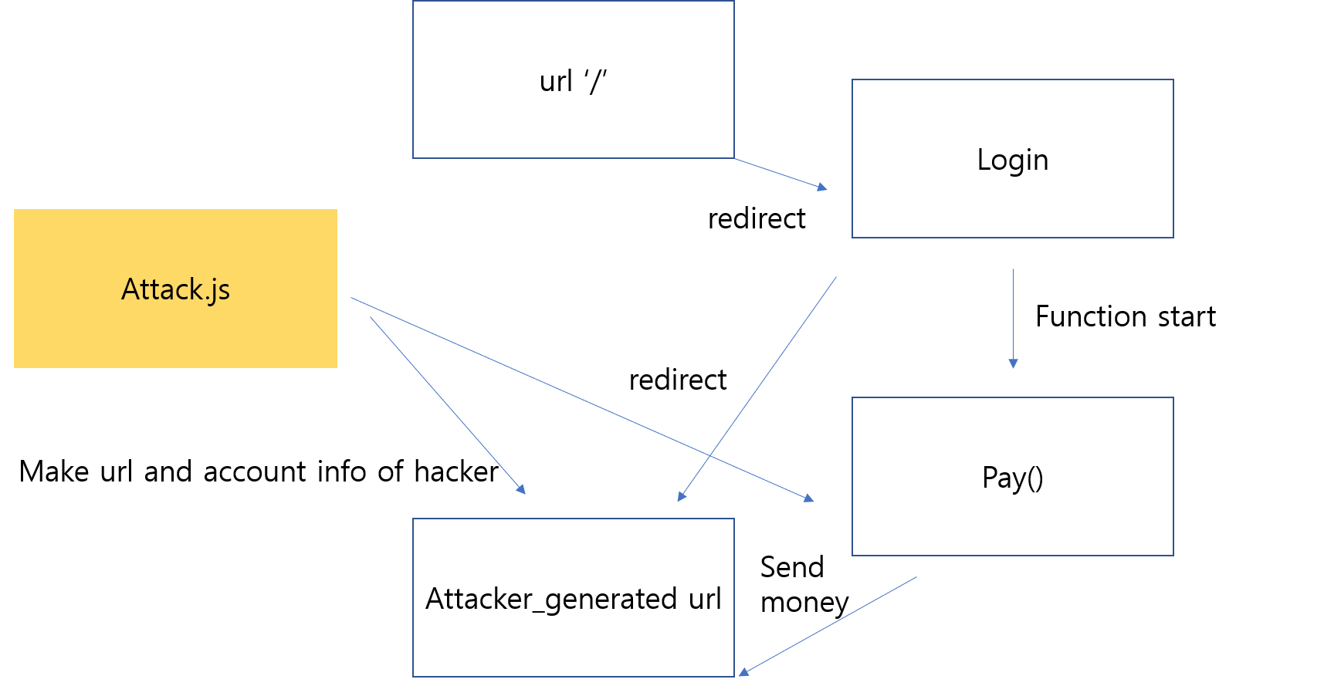

There are attack.js for generating hacker’s url to deceive user, Login for getting user information. There is index.html which is directed by attacker-generated url that shows user account’s information, flash message and logs. Pay function takes its roll for sending money to hacker from user’s account that has been gotten from login.html.

When the user named brandon enters his information in Login page, Attack.js generates url based on information of hacker. It makes user to enter the url made by hacker and starts pay() function that sends money to hacker’s account. And then shows the index page on Attacker_generated url that shows not-suspicious flash messages and account logs.

1. **Specification of program**

Attack.js generates url and sends it. And that url is stored in the global variable named ‘url’ and used frequently. If client is directed to this url, server shows index.html on the browser.

If user puts his information in the login page, they are stored as cookie. So the pay() function and index(hacker generated url(page)) usess it to send money from his account and show the log of account.

To make the hacker’s page unsuspicious, attack.js sets flash message as “Thanks, Brandon”.

If user re-enters in attacker’s url, it sends money out of user’s account again and again every time he enters that page due to pay() instruction written in index function.